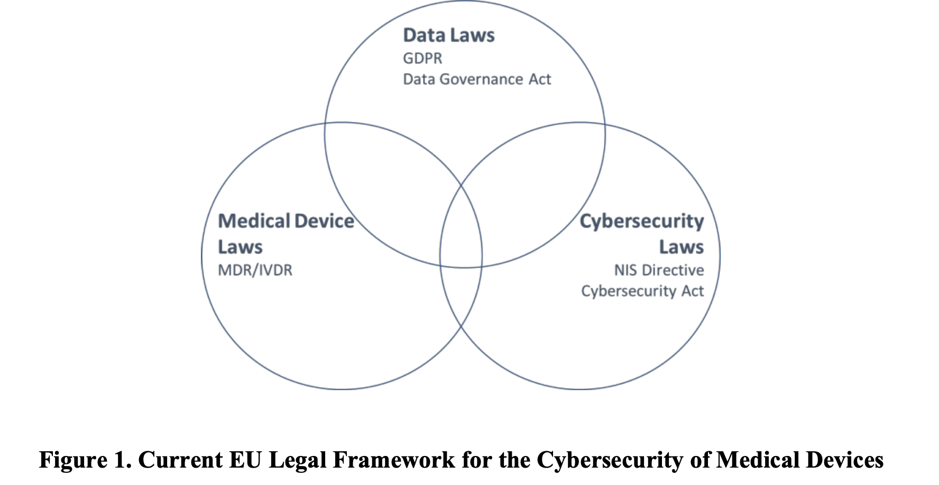

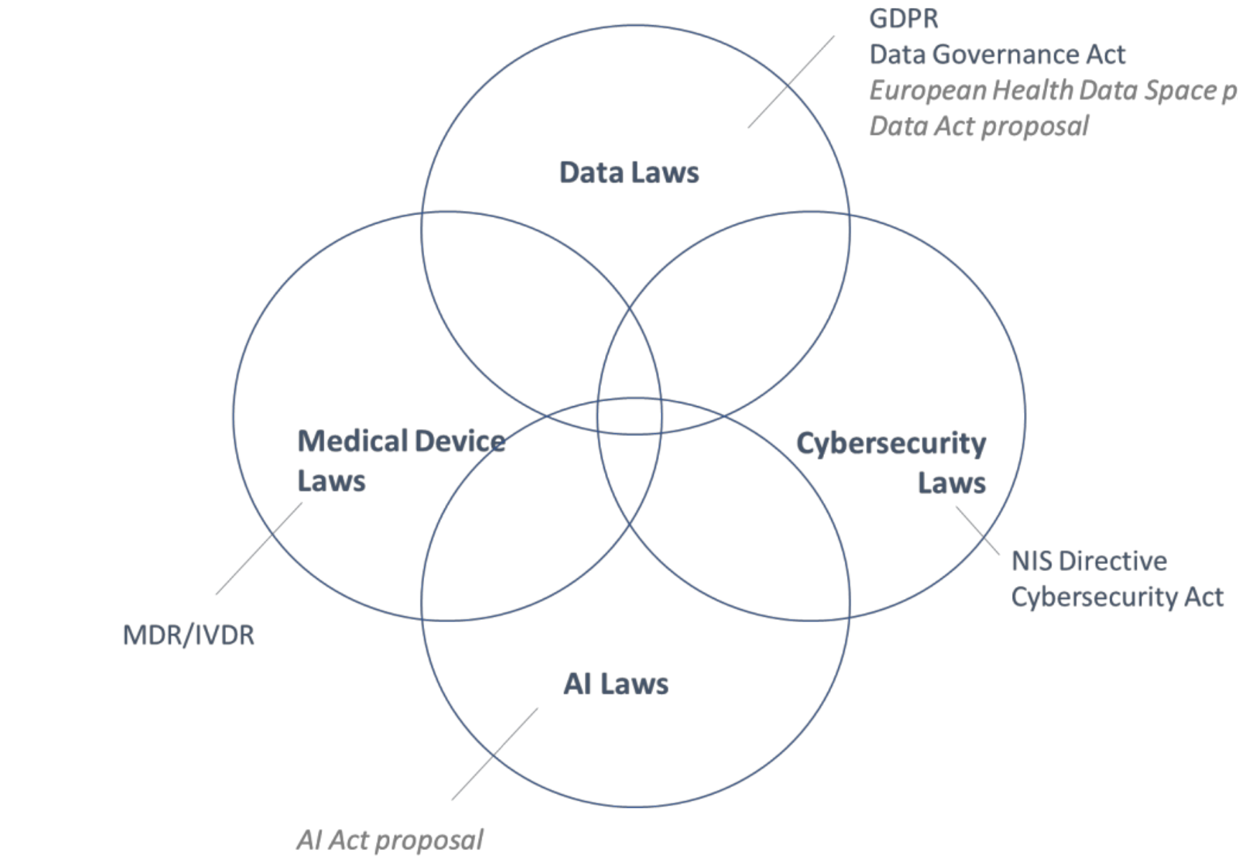

Existing Legislation

1. Medical Device Regulation (MDR) (Regulation (EU) 2017/745)
Definition of Medical Device:
  - Article 2(1): Defines a medical device as:
“Any instrument, apparatus, appliance, software, implant, reagent, material, or other article intended by the manufacturer to be used, alone or in combination, for human beings for one or more of the following specific medical purposes:
    - Diagnosis, prevention, monitoring, prediction, prognosis, treatment, or alleviation of disease.
    - Investigation, replacement, or modification of the anatomy or a physiological or pathological process.
    - Providing information by means of in vitro examination of specimens derived from the human body, including organ donation.”
  - This broad definition ensures that software integrated into medical devices is also included, addressing cybersecurity concerns for digital systems.
Cybersecurity-Related Provisions:
Annex I, Section 17 (General Safety and Performance Requirements - GSPR):
17.2: Mandates that devices are designed and manufactured to ensure protection against unauthorized access and cyber risks that could compromise device performance or data integrity.
17.4: Requires devices to maintain confidentiality, integrity, and availability of data through state-of-the-art cybersecurity measures, including encryption and secure user authentication.
Guidance:
MDCG 2019-16:
    - Clarifies pre-market and post-market cybersecurity requirements for medical devices.
    - Highlights the need for a risk management system addressing cybersecurity risks during the product lifecycle.
    - Recommends incident reporting protocols for serious cybersecurity breaches affecting device safety or performance.

2. Network and Information Systems (NIS2) Directive (Directive (EU) 2022/2555)
Definition of Critical Entities:
Article 3: Defines “essential entities,” including:
"Entities involved in the manufacturing of medical devices and in vitro diagnostic devices listed under Annex II of the directive."
Cybersecurity-Related Requirements:
Article 21: Outlines cybersecurity risk management measures, including:
    - Adoption of policies addressing technical, organizational, and operational risks.
    - Regular assessments of vulnerabilities in medical devices and systems.
    - Reporting obligations for cybersecurity incidents to national authorities within 24 hours of detection.
Annex II: Lists "essential and important entities," including medical device manufacturers, requiring them to comply with NIS2 measures for supply chain security and incident reporting.

3. Cybersecurity Act (CSA) (Regulation (EU) 2019/881)
Definition of Cybersecurity:
Article 2(1): Defines cybersecurity as:
“The activities necessary to protect network and information systems, the users of such systems, and other persons affected by cyber threats.”
- This definition emphasizes both technical and user protections, aligning with a broader understanding of cybersecurity.
Cybersecurity Certification:
  - Establishes a voluntary certification framework for ICT products, including medical devices.
  - Certifications ensure compliance with EU cybersecurity standards, promoting user trust in certified devices.

4. General Data Protection Regulation (GDPR) (Regulation (EU) 2016/679)
Key Provisions:
Article 32: Mandates technical and organizational measures to protect personal data, including encryption, pseudonymization, and access controls.
Articles 33-35: Requires data breach notifications within 72 hours and impact assessments for high-risk processing activities, such as medical device operations.

5. Data Governance Act (DGA) (Regulation (EU) 2022/868)
Secure Processing Environments:
Article 2(14): Defines a secure processing environment as:
“A physical or virtual environment and organizational means ensuring compliance with Union law, particularly in regard to data subjects’ rights, intellectual property rights, and commercial confidentiality.”
- These environments are essential for public sector data reuse and include health data processed by medical devices.

Forthcoming Legislation

1. Artificial Intelligence Act (AI Act) (Proposal COM/2021/206 final)
Definition of High-Risk AI Systems:
Article 6: Categorizes medical device AI as "high-risk" if it constitutes:“A product or safety component of a product covered under EU safety legislation listed in Annex II.”
- Includes systems used for diagnostics, monitoring, or treatment that require conformity assessments under MDR.
Cybersecurity-Related Provisions:
Article 15(1): Requires high-risk AI systems to achieve an “appropriate level of accuracy, robustness, and cybersecurity.”
Article 15(4): Mandates resilience against unauthorized access and exploitation, with measures addressing data poisoning, adversarial examples, and other vulnerabilities.
- Recital 5a of the Artificial Intelligence Act (AI Act):
It is necessary to address ‘cybersecurity concerns’ to ensure that AI systems are in line with EU values.

2. European Health Data Space Regulation (EHDS) (Proposal COM/2022/197 final)
Key Provisions:
1. Article 2(2)(n): Defines electronic health record (EHR) systems as appliances or software intended for handling health data (e.g., storage, editing, or viewing).
2. Article 50: Specifies measures for secure processing environments to safeguard shared health data:
    - Access Management:
      - Data access must be restricted to authorized personnel, with role-based access controls.
    - Logging Mechanisms:
      - Every data access, modification, or deletion must be recorded for traceability.
    - Digital Signature Support:
      - Data systems must support digital signatures to authenticate users and ensure data integrity.
    - Retention and Access Rules:
      - Data storage must adhere to defined retention periods and differentiated access rights for various user roles.
    - Monitoring Mechanisms:
      - Systems must continuously monitor for unauthorized access and cybersecurity breaches.
    - Encryption and Pseudonymization:
      - Data shared or processed in these environments must be encrypted and, where possible, pseudonymized to protect patient identities.
3. Annex II: Includes cybersecurity requirements for health data handling, specifying that systems must adhere to common specifications issued by the European Commission.

3. Data Act (Proposal COM/2022/68 final)
Key Provisions:
Article 14: Mandates data sharing with public authorities during emergencies, such as major cybersecurity incidents or natural disasters.
Article 15: Specifies conditions for sharing, including:
  - Data protection through encryption during transit and at rest.
  - Access restrictions ensuring only relevant authorities can view sensitive information.
Article 2(10): Defines public emergencies as situations negatively affecting populations or economic stability, including cybersecurity incidents.

Challenges in Current Legislation
- Fragmentation and Lack of Harmonization:
Challenge:
    - Multiple overlapping laws (MDR, NIS2, GDPR, EHDS) lead to inconsistencies in requirements and enforcement.
    - Fragmentation arises due to national-level implementation of directives like NIS2, causing varied cybersecurity standards across EU member states.
Example:
Case: Single Resolution Board v. European Data Protection Supervisor (2023):
Facts: A dispute on how anonymization under GDPR was interpreted across different jurisdictions.
Held: The European Court of Justice (ECJ) expanded the interpretation of anonymized data, considering the potential for re-identification only by the data-sharing entity.
Outcome: Highlighted the risks of inconsistent application of laws across the EU.
Scholar’s Opinion:
Biasin (2023): Argues that the EU's fragmented legal framework hinders the goal of achieving uniform cybersecurity for medical devices.

- Overlapping and Conflicting Provisions:
Challenge:
    - MDR and EHDS overlap in defining health data security and the scope of medical devices.
    - Manufacturer intent in the EHDS regulation leaves room for circumvention; devices that process health data may evade regulation if not explicitly declared as EHR systems by manufacturers.
Scholar’s Opinion:
Kamenjašević: Points out the ambiguity in the EHDS regulation regarding whether medical devices qualify as EHR systems, leading to unclear compliance obligations.

- Inadequate Scope of Security Requirements:
Challenge:
    - MDR and GDPR emphasize safety and data privacy but lack provisions for advanced threats like adversarial AI attacks.
    - The AI Act proposal requires technical solutions but does not mandate organizational measures like impact assessments.
Example:
Case: Cambridge Analytica Data Breach:
Facts: Highlights the lack of organizational measures in securing data systems.
Outcome: Demonstrated that technical measures alone are insufficient without robust governance and oversight.
Scholar’s Opinion:
Orlando and Dewitte: Advocate for including interdisciplinary measures to address security challenges comprehensively.

- Insufficient Security for Data Sharing:
Challenge:
    - EHDS’s provisions for secure processing environments are vague, leaving gaps in protecting health data against re-identification risks.
    - The Data Act’s notion of “major cybersecurity incidents” lacks clarity, creating uncertainty around emergency response protocols.
Example:
Case: Equifax Data Breach:
Facts: Poorly defined security standards led to a major data leak impacting millions of individuals.
Outcome: Highlighted the need for precise definitions and protocols in handling cybersecurity incidents.
Scholar’s Opinion:
Papakonstantinou: Criticizes the limited focus on re-identification risks, emphasizing the need for stricter anonymization standards.

Proposals to Address Challenges
1. Harmonize Definitions and Frameworks:
Proposal:
    - Align definitions (e.g., cybersecurity, anonymization) across CSA, NIS2, and GDPR to ensure consistency.
    - Clarify overlaps between MDR and EHDS to define clear boundaries for cybersecurity responsibilities.
Scholar’s Opinion:
Fuster: Recommends a unified framework to prevent legal conflicts and duplication of efforts.

2. Include Organizational Measures in Security Requirements:
Proposal:
    - Extend the AI Act to mandate organizational measures like impact assessments, institutional oversight, and complaint mechanisms.
    - Enhance MDR to require interdisciplinary collaboration between engineers and legal professionals.
Scholar’s Opinion:
Bygrave: Advocates for integrating security-by-design principles into organizational policies, not just technical systems.

3. Strengthen Anonymization and Data Security Standards:
Proposal:
    - Tighten EHDS’s provisions for secure processing environments to include mandatory re-identification risk assessments.
    - Expand Article 45(4) of EHDS to apply stricter safeguards to both anonymized and pseudonymized data.
Example:
Case: Google Spain SL v. Agencia Española de Protección de Datos (2014):
Facts: Revolved around data privacy and re-identification risks.
Held: ECJ emphasized the necessity of protecting personal data under GDPR.
Outcome: Set a precedent for enhancing anonymization standards.
Scholar’s Opinion:
Michalec: Suggests a proactive approach to anonymization, given the increasing sophistication of re-identification technologies.

4. Clarify Emergency Protocols in the Data Act:
Proposal:
    - Define “major cybersecurity incidents” with specific criteria aligned with NIS2 or CSA.
    - Introduce notification duties for health data access bodies under EHDS.
Scholar’s Opinion:
Ducuing: Warns against vague emergency provisions, which may undermine trust in data-sharing systems.

5. Promote Interdisciplinary Collaboration:
Proposal:
    - Foster collaboration between technical and legal experts to ensure holistic cybersecurity.
    - Mandate cross-disciplinary training for entities handling medical device cybersecurity.
Scholar’s Opinion:
Orlando and Dewitte: Highlight the necessity of interdisciplinary strategies to address the complexity of cybersecurity in medical devices.

European Parliament, Draft Compromise Amendments on the Draft Report, 16 May 2023, Recital 5a. Recital 5a serves as interpretive guidance, emphasizing the importance of cybersecurity in aligning AI systems with foundational EU principles such as safety, human rights, and technological reliability. Original 5a: At the same time, depending on the circumstances regarding its specific application, use, and level of technological development, AI may generate risks and cause harm to public interests and fundamental rights that are protected by Union law. Such harm might be material or immaterial, including physical, psychological, societal or economic harm.

